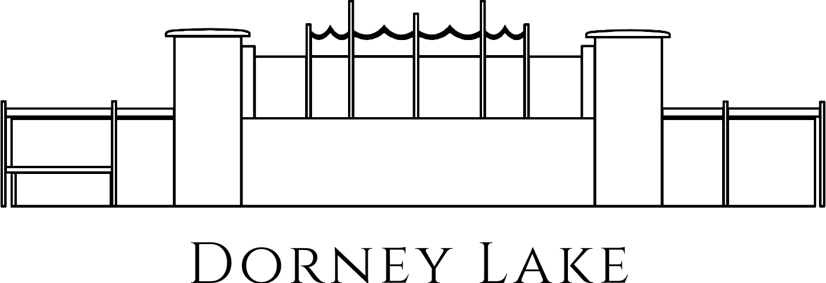

FILMING APPLICATION FORM

Please complete this application as fully as possible and submit at the earliest opportunity.

PLEASE NOTE THAT WE DO NOT ALLOW DRONE FILMING FROM OR OVER THE VENUE.
Please return signed and completed applications to:
Eton College Dorney Lake, Off Court Lane, Dorney, Buckinghamshire, SL4 6FJ or info@dorneylake.co.uk

Data Protection Statement – Data Protection Act 2018 1
The information you provide on this form will only be processed for the purpose for which it has been given. All personal data is processed in compliance with applicable Data Protection legislation. Our Privacy Notice provides more detail about how we use personal data.
*Please note that this does not confirm your booking.

Name of Organisation/Company
Named Organiser
Main Contact or Organisers Address for Correspondence & Invoicing
Work/Home Telephone No | Mobile Telephone No |  | Email Address

Filming Details 2

Identify which part of the site you wish to use for filming use | Lakeside/Land based On the Lake  Pay & Display Car Park at Main Entrance (Nr Dorney Court)  (hirer to arrive 3 hours prior to hire to cone/close off car park)  Main Car Park (Nr Church) Room Hire  Ramblers’ Car Park (Nr Church)

Please tell us the dates you are requesting for access and for the filming event.

Access Start Date |  |  | Start Time
Access End Date |  |  | End Time
Filming Days

Please indicate if extra time is needed before or after your event (e.g. setting up, or removal of equipment from site). Please provide the dates of required access.

Filming Start Date / Time |  |  | End Date / Time

Total duration on site......................................

Number of Crew / Vehicles 3
Please state number of crew anticipated………………………………………………………………………….

Number and type of vehicles ………………………………………………………………………………………

Any V.I.P./Press Interests ………………………………………………………………………………………….

Public Liability Insurance 4
This is an essential requirement for all activities. Adequate cover provided by such policies is normally in the region of £10 million and arranged through an Insurance Broker by the Organiser. Approval to film will be refused if you fail to provide this information.

Copy of certificate enclosed | Yes |  | No
A copy of the public liability must be provided before the filming takes place.

Risk Assessments 5

A copy of your event risk assessments will be required. Risk assessments are an important step to protecting organisers, as you are required to protect people as far as reasonably practical.

Copy of risk assessments enclosed | Yes |  | No
A copy of the risk assessments must be provided before the filming takes place,

Filming Details 6
Please provide details below of what is being filmed & any works required. Please specify in as much detail as possible any proposed works that may be required to alter the location in any way. Please include any works required to support the filming (for example marquees, portacabins, set building, tents, special effects etc): *Everything must be returned to its original state or you may be charged if Dorney Lake have to return the site to its original state, including administration costs, unless otherwise expressly agreed with the Managing Director.

Additional Requirements 7

Stand Pipe for Water Supply (a daily consumption charge rate will be applied in line with current charges)

Catering (please specify)……………………………………………………………….

Room Hire (please give details of times)……………………………………………..

Safety Boat Hire with Driver……………………………………………….

Drone use………………………………………………………………….

Site Conditions 8

Please confirm that you will adhere to and facilitate all of the following site conditions:

All refuse must be cleared and taken from site Grey/Foul Water to be taken off site
(not disposed of down the drains)

Any Generators to be silent-run 24 hour Security must be provided

Signed on behalf of Production Company: 9

Name:
Signed:

We will contact you once we have reviewed your initial application for
more information, and/or a quotation.

Terms & Conditions
In the event that filming permission is granted:
- You and/or your company will be responsible for all legal claims for personal injury and or damage to property due to your company’s negligence or that of your servants or agents arising directly out of the activities in connection with the proposals which you have submitted.
- You and/or your company will be required to leave all sites and locations in a tidy and clean condition, and obey all safety, and other relevant instructions given to them by any authorised representative of Dorney Lake, which may include an instruction to stop activity if necessary.
- You and /or your company will agree to pay the reasonable cost of making good any damage which may occur to the land or any property as a result of the proposed activity (including any professional fees spent evaluating or negotiating the claim).
- As a public site we cannot control who is on or off site, so site security is the responsibility of the film company.
- All vehicles, items and belongings are left at own risk.

